**PROJECT TITLE**

**Ordering a WiFi Router via ServiceNow Service Catalog**

**Project Description:**

The objective of this ServiceNow project is to learn how to effectively streamline IT equipment requests, specifically by enabling a user-friendly process for requesting a WiFi router, integrating necessary managerial approvals to ensure proper resource allocation, and automating order processing to enhance the efficiency and reliability of service delivery for remote employees.

**Team members**

* JAYASREE.S
* NIRANJANA DEVI M.C
* ABINAYA K
* MINHAS MOHHAMMED

**Implementations**

**STEP 1:**

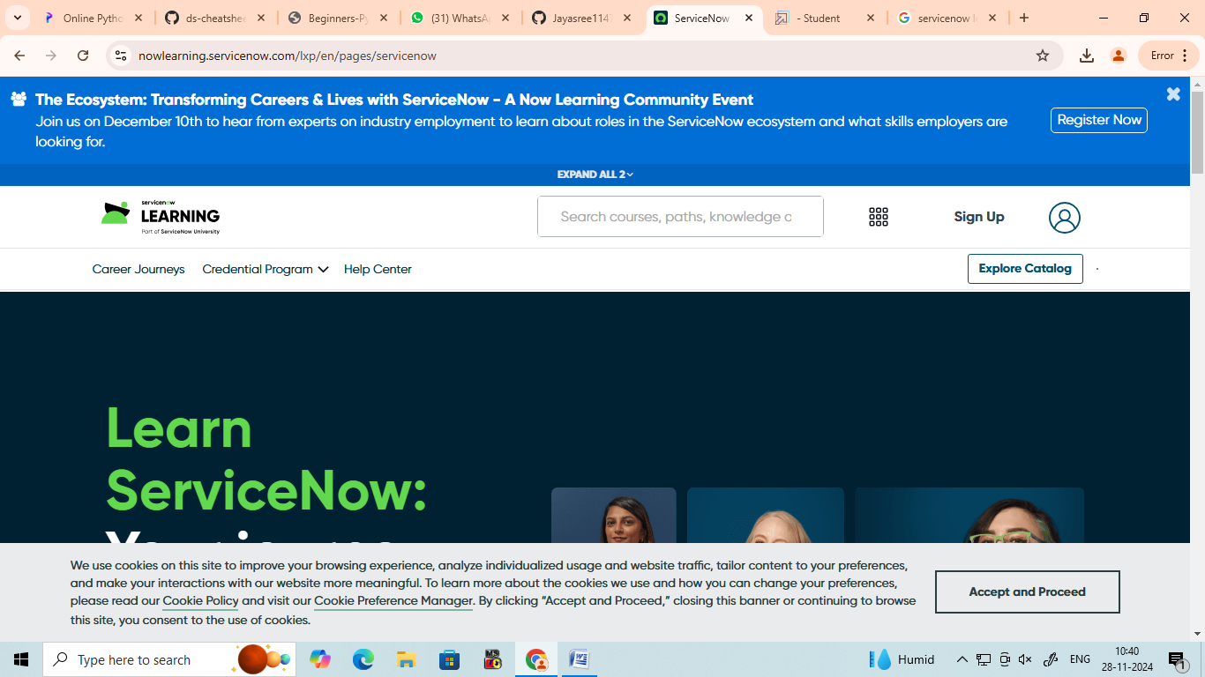

**STEP 2:**

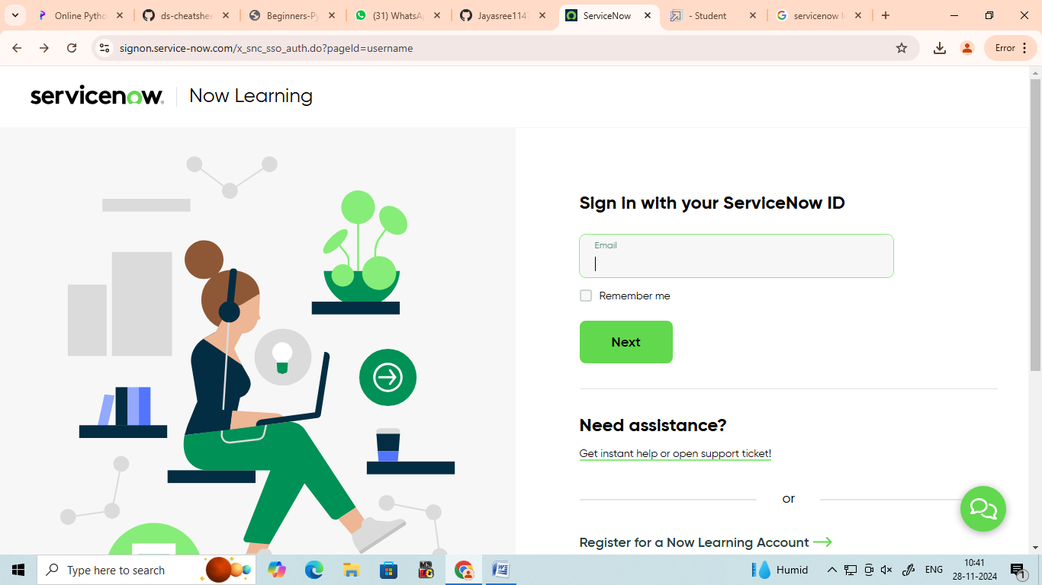

**STEP 3:**

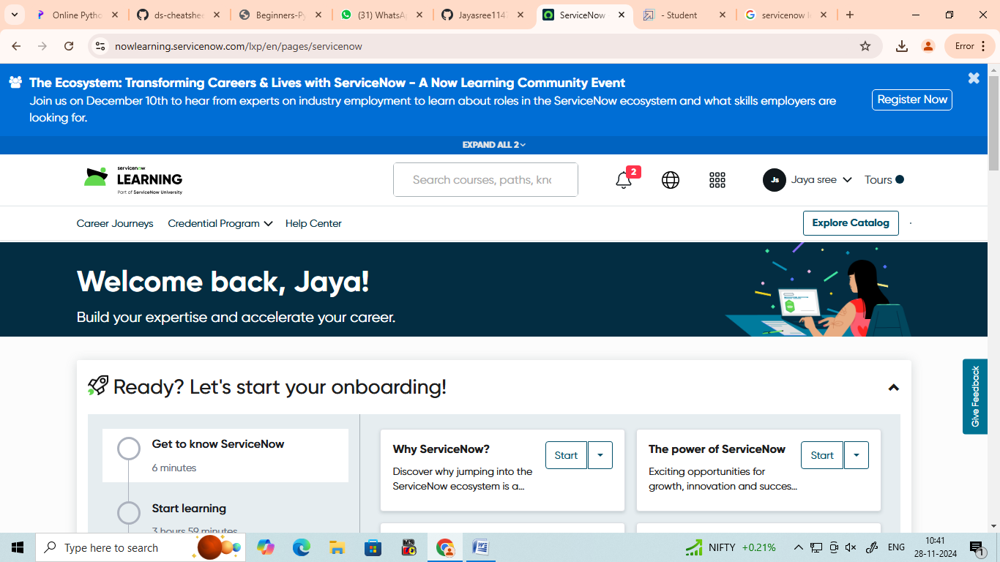

**STEP 4:**

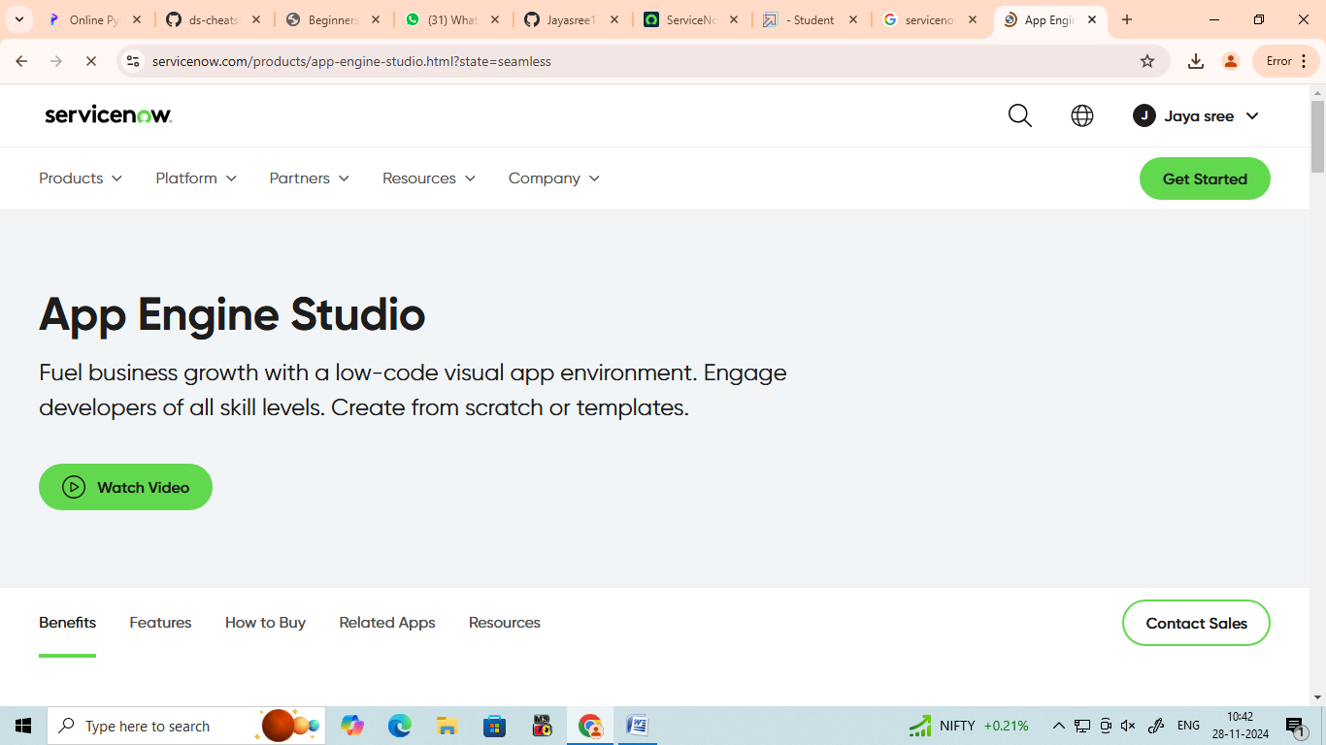

**STEP 5:**

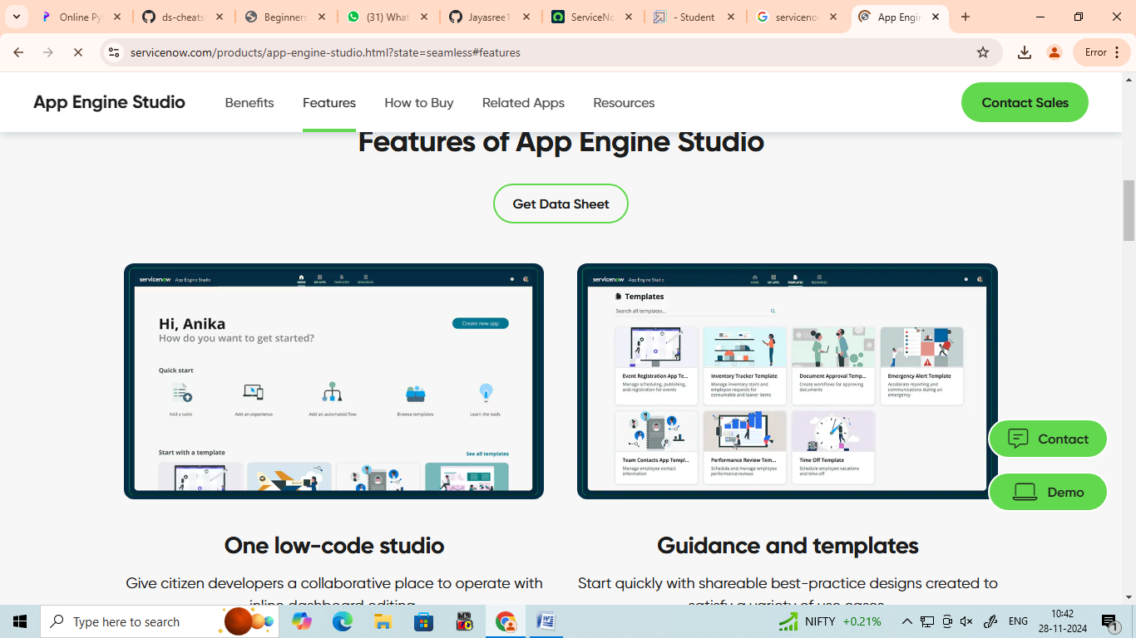

**STEP 6:**



**STEP 7:**

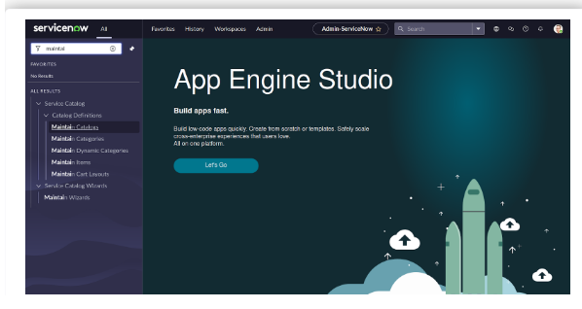

**STEP 8:**

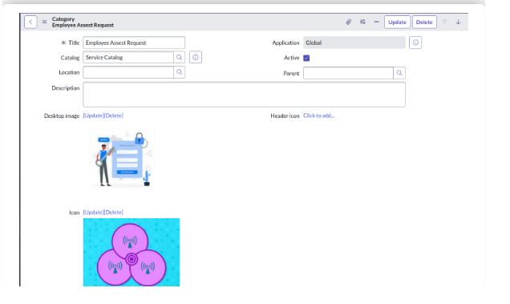

**STEP 9:**

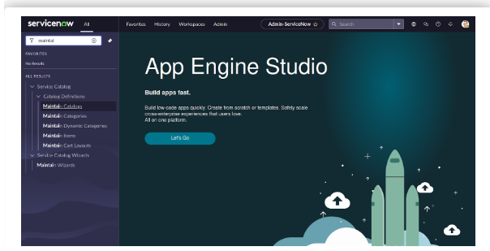

**STEP 10:**

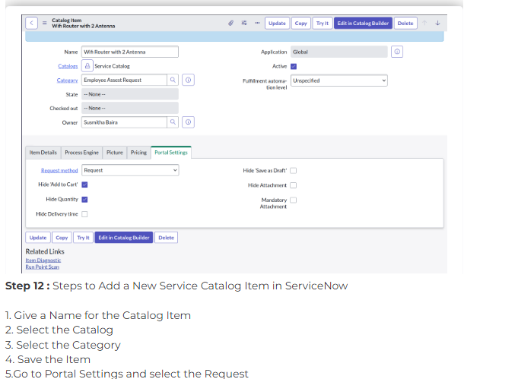

**STEP 11:**

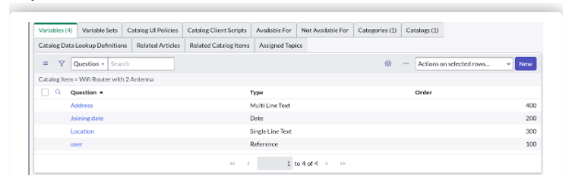

**STEP 12:**

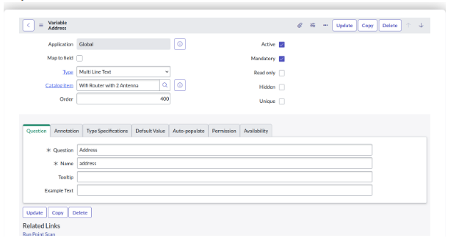

**STEP 13:**

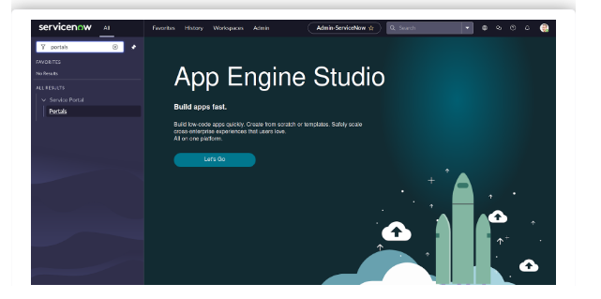

**STEP 14:**

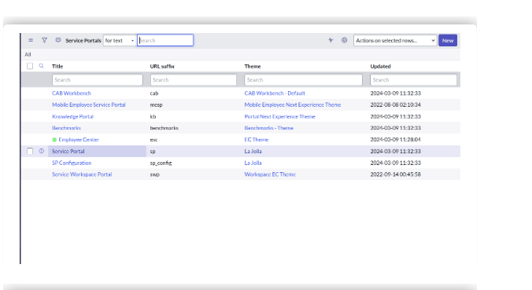

**STEP 15:**

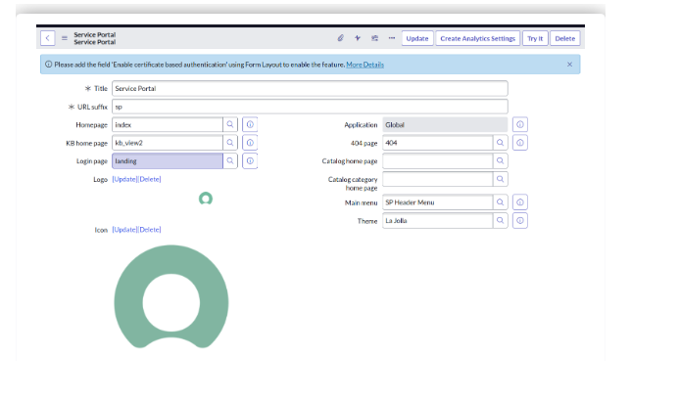

**STEP 16:**

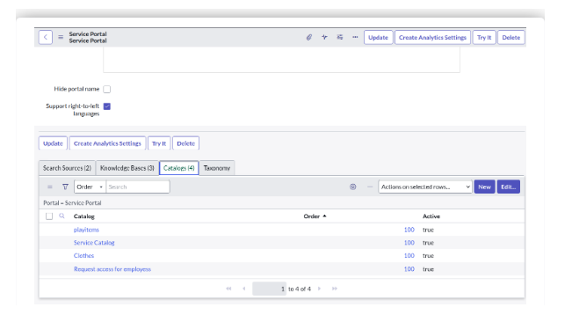

**STEP 17:**

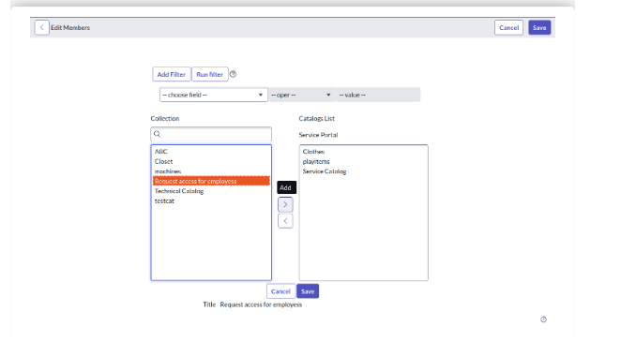

**STEP 18:**

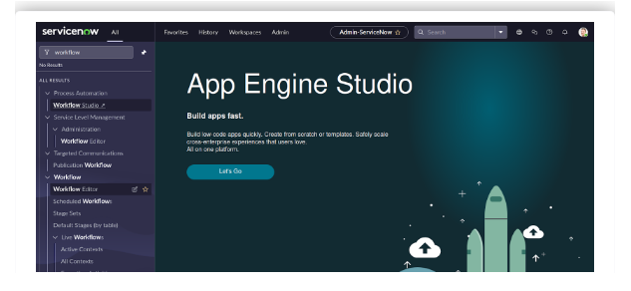

**STEP 19:**

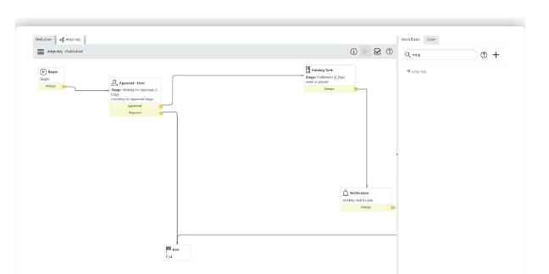

**Workflow for process Automation**

**STEP 20:**

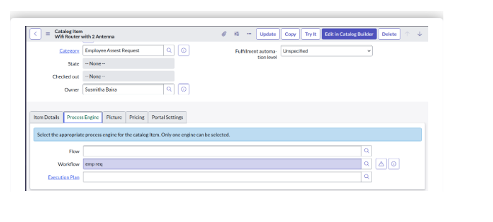

**STEP 21:**

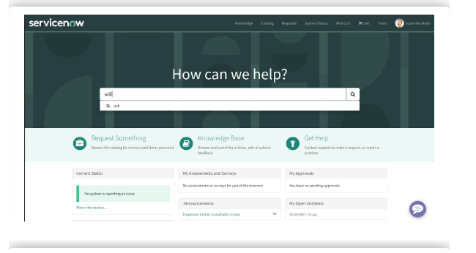

**STEP 22:**

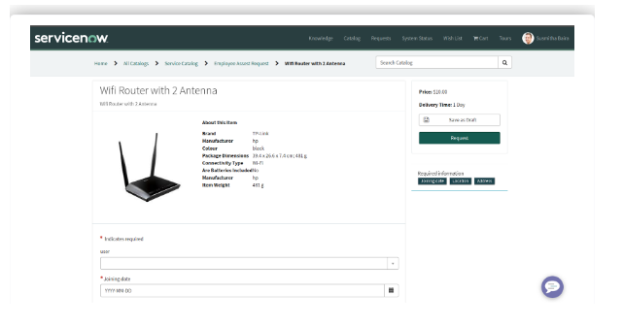

**STEP 23:**

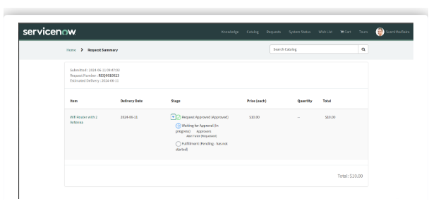

**STEP 24:**

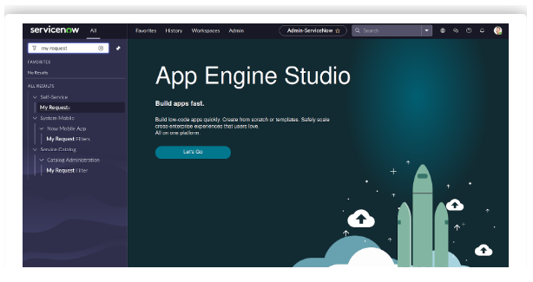

**STEP 25:**

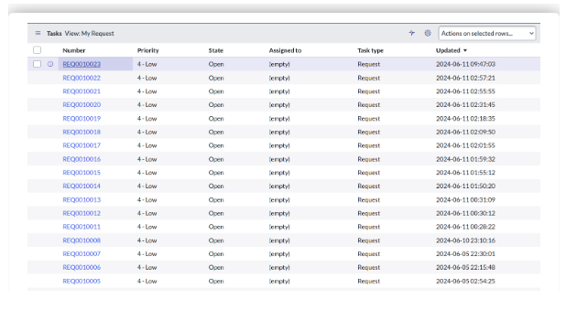

**STEP 26:**

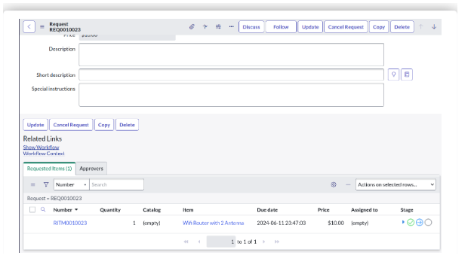

**STEP 27:**

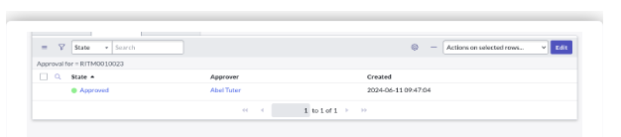 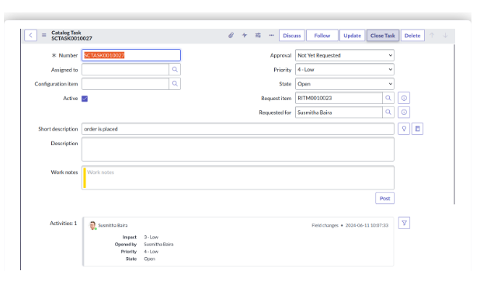

**Result implementation**

**STEP 1:**

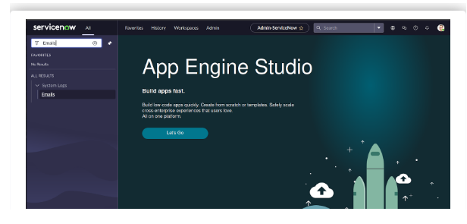

**STEP 2:**

